Current Hot Over Stocks
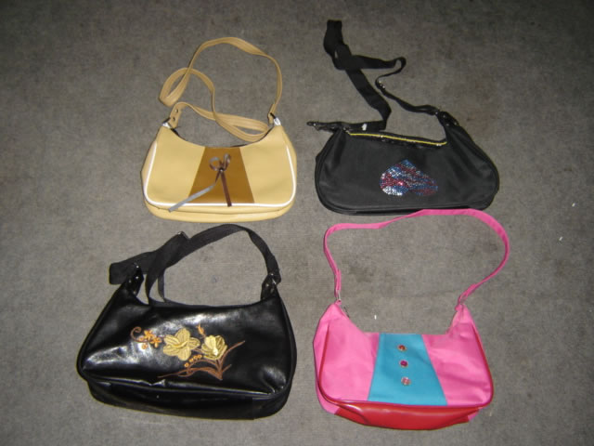 | 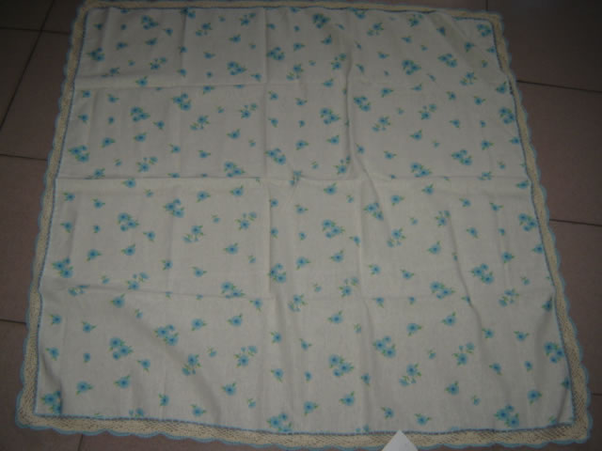 | 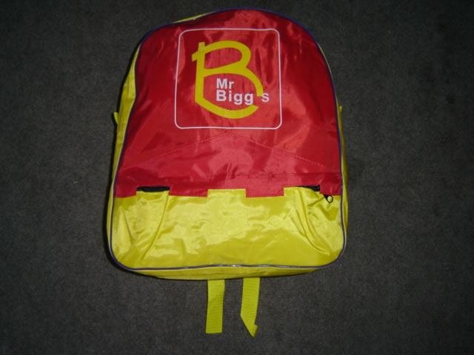 | 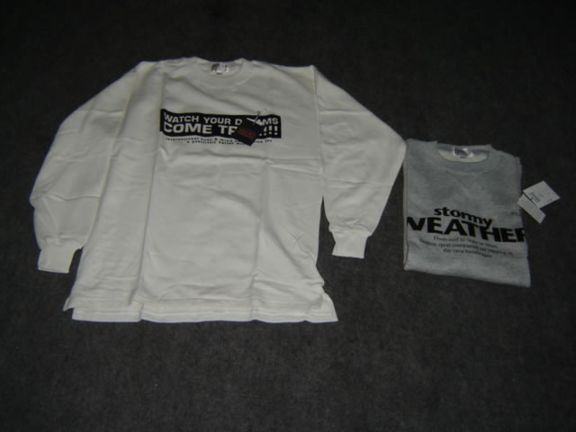
Item #: YC2167a  Product: lady’s bag  Quantity: 1500pc  price: 5.5RMB/pc  material: Leather | Item #: YC2482b  Product: table cloth  Quantity: 2200  price: 6.5RMB/  dimension: 150*120cm  fabric: linen55% cotton 45% 1/PP | Item #: YC1910c  Product: school bag  Quantity: 1500pc  price: 4.4RMB/pc  packaging: 100pc/carton，1pc/PPbag  dimension: 38*30*9.5cm  material: raincoat cloth | Item #: YC1169b  Product: sport wear  Quantity: 1500  price: 9RMB/pc  color: 4-  fabric:：100%cotton export to Japan originally  packaging: 1pc/plasticbag，
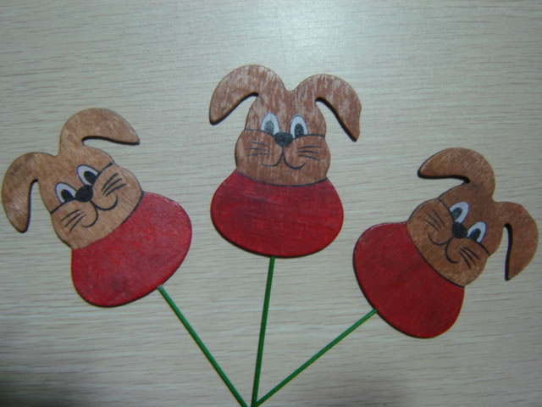 | 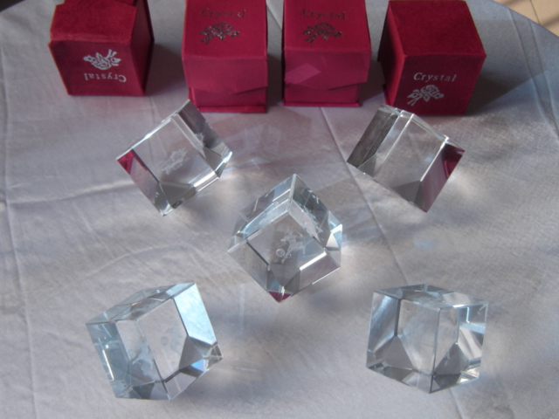 | 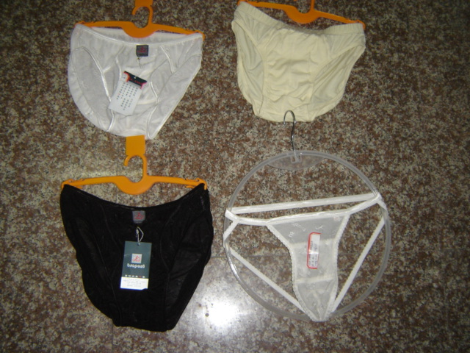 | 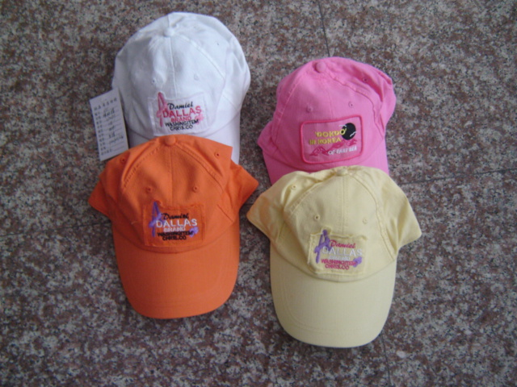
Item #: YC2628  Product: aim  Quantity: 24480pc  price: 0.25 RMB/pc  colors  size: 8*9.5CM handle: 8CM  packaging: 12pc/dozen 120dozen/carton  1440pc/carton | Item #: YC2670  Product: 12 signs of the zodiac crystal  Quantity: 3059pc(12 signs)  price: 2 RMB/pc  size: 4*4*4CM  packaging: 1pc/P bag 168pc/carton 38*30*21CM | Item #: YC2626  Product: mens underwear  Quantity: 3035pcs 4styles  price: 2.3RMB/pc  note: always in stock | Item #: YC2715  Product: baseball cap  Quantity: 5720pc 4colors  price: 2.85RMB/pc  note: always in stock
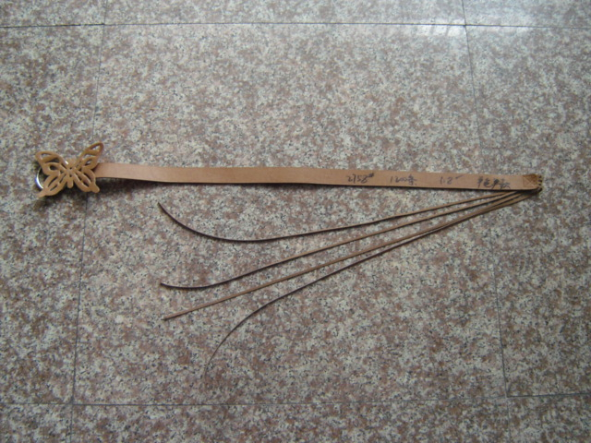 | 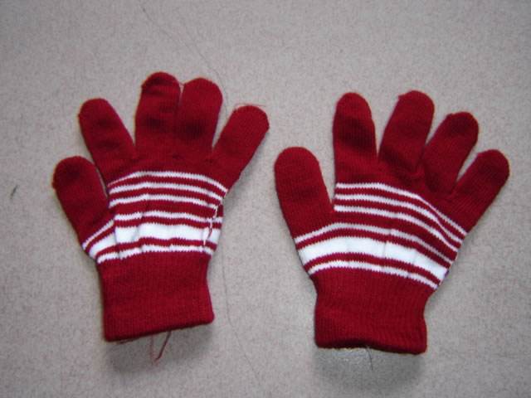 | 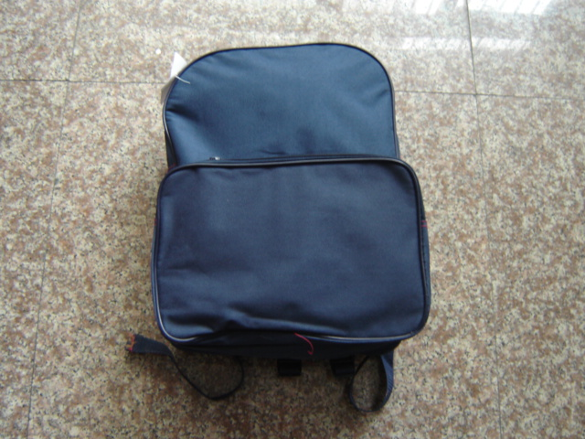 | 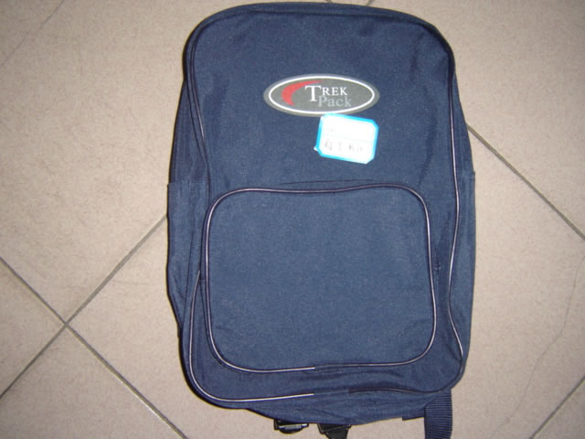
Item #: YC2758  Product: lady’s belt  Quantity: 1200  price: 2.2RMB/pc  note: always in stock | Item #: YC2276  Product: magic gloves  Quantity: 10000pair  price: 0.94 RMB/pair  color: 6colors | Item #: YC2650A  Product: school bag  Quantity: 5000pc  price: 5 RMB/pc  size: 30*12*35CM  packaging: 240pc/carton  note: always in stock | Item #: YC2650C  Product: school bag  Quantity: 5000pc  price: 4.5RMB/pc  size: 24*8*34CM  packaging: 360pc/carton
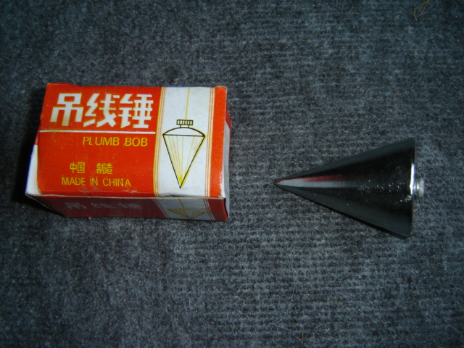 | 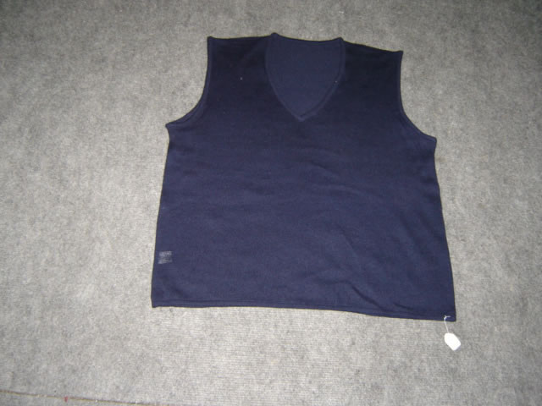 | 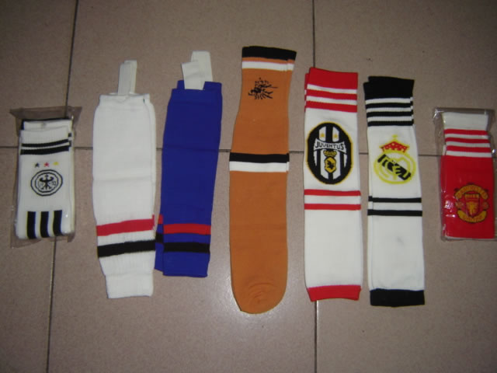
Item #: YC2532c  Product: plumb bob  Quantity: 240pc  price: 3.3RMB/pc  size: 8cm*6cm 600g  packaging: 2pc/box 60pc/carton | Item #: YC1169c  Product: wool shirt  Quantity: 15000  price: 3.8RMB/pc  color: 1 | Item #: YC2599  Product: sport socks  stockings 1560pair 0.9 RMB/pair  socks 600pair 0.95RMB/pair  footsock 5600pair 0.95RMB/pair  packaging: 1pair/PP 1000pair/carton
All prices are ex-works or ex-factory. 1USD = 7.97RMB To get the USD prices, just divide the quoted RMB value by 7.97

